QA Test Execution Report: E2E Checkout Flow
1. Project Overview
This report documents the automated end-to-end (E2E) testing of the checkout process for the Automation Exercise e-commerce platform. The primary goal is to ensure that registered users can successfully complete a purchase, maintaining the platform's most critical business path.
Automation Tool: Ghost Inspector (Cloud-based No-Code Automation)
Platform Tested: https://automationexercise.com/
Environment: Production/Staging Simulation
2. Test Case Specification
Field | Details
Test ID | CT-001
Title | Standard Checkout Flow for Registered Users
Priority | High (Critical Path)
Pre-conditions | User account previously registered; Browser navigated to the login page.
Test Steps and Expected Results
# | Step Action | Expected Result
1 | Navigate to login and enter valid credentials. | User is logged in; Authentication message is visible.
2 | Add a product to the cart and navigate to checkout. | Product added successfully; Delivery details are displayed.
3 | Complete payment form and confirm order. | Order is placed successfully; "ORDER PLACED!" message appears.

3. Execution Evidence (Screenshots)
The following screenshots provide visual evidence of the test execution performed on the Ghost Inspector cloud platform.
3.1. Test Execution Dashboard Overview
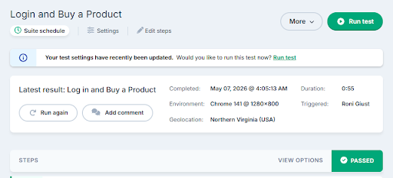
3.2. Login Assertion (XPath Validation)
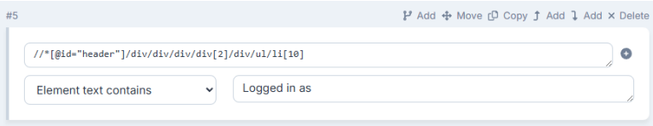
3.3. Final Order Confirmation & Visual Regression

4. Technical Analysis & Findings
Execution Status: PASSED
Technical Highlights:
- Selector Resilience: Implemented robust XPath selectors (e.g., //a[contains(., 'Logged in as')]) to handle nested tags and dynamic content, reducing test brittleness compared to generic CSS selectors.
- Visual Regression Testing: Enabled visual comparisons for the final confirmation screen with a 10% tolerance threshold. This ensures UI stability while allowing for minor rendering variations in cloud-based browser environments.
- Automated Validation (Assertions): Integrated explicit assertions to verify authentication state before proceeding with the checkout flow, preventing false positives.

Conclusion:
The automated test successfully validated the critical path of the application. The use of advanced selectors and visual regression provides a high level of confidence for future production deployments.

